Testing for all the graphs:

Graph18: LPP_Trend_Analysis_Amounts

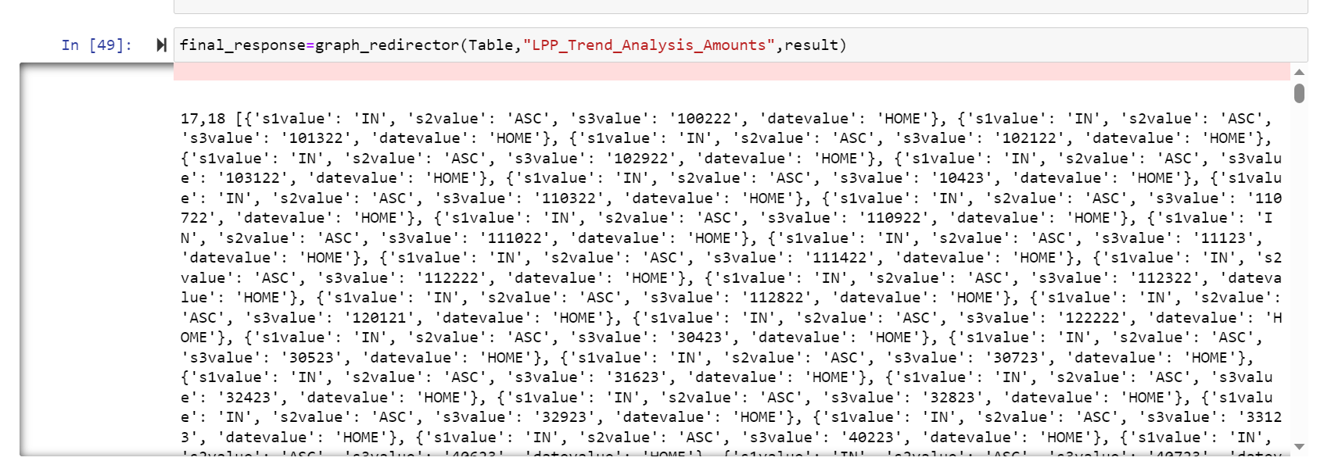

Graph17: Trend_Analysis_Amounts

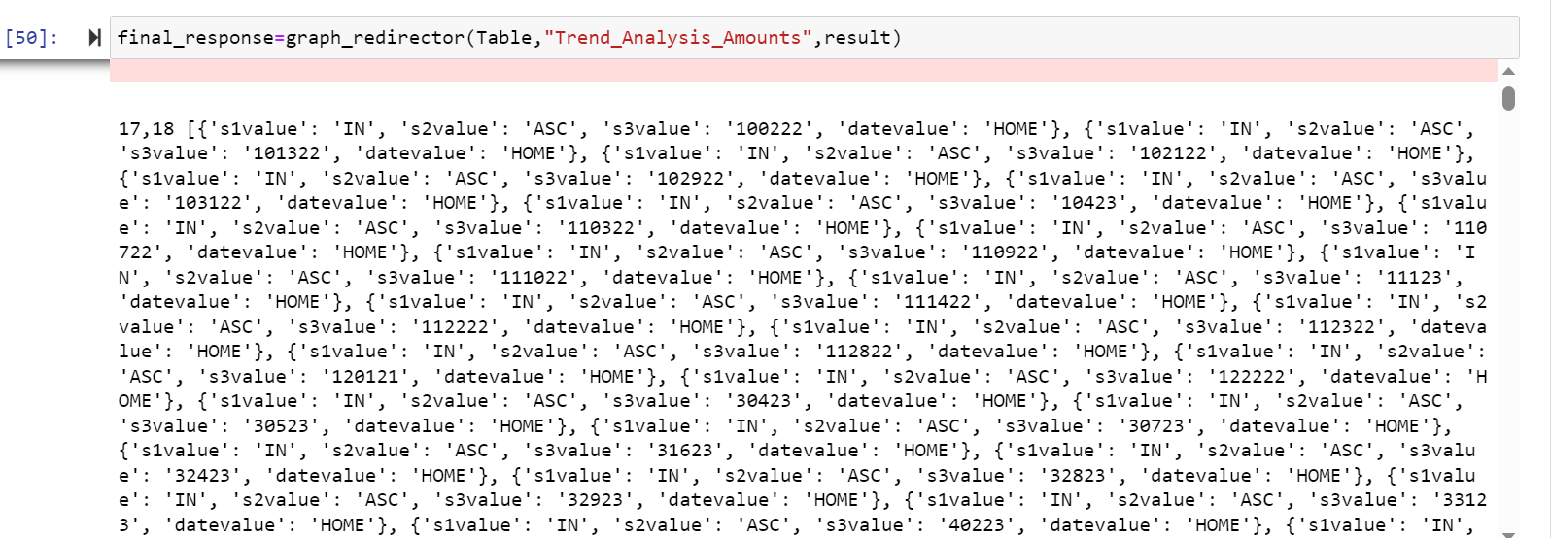

Graph16: Trend_Analysis_Claims_Volumns

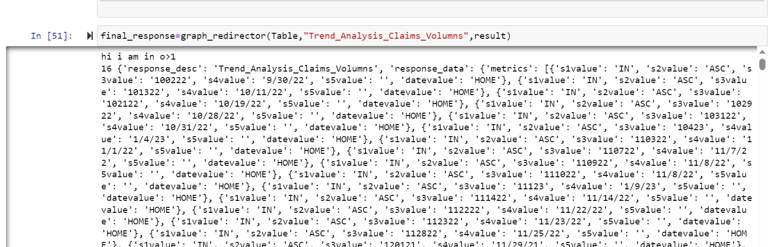

Graph15,14,13:

MYSQL data issue hence did not perform

Graph 1:population_volume

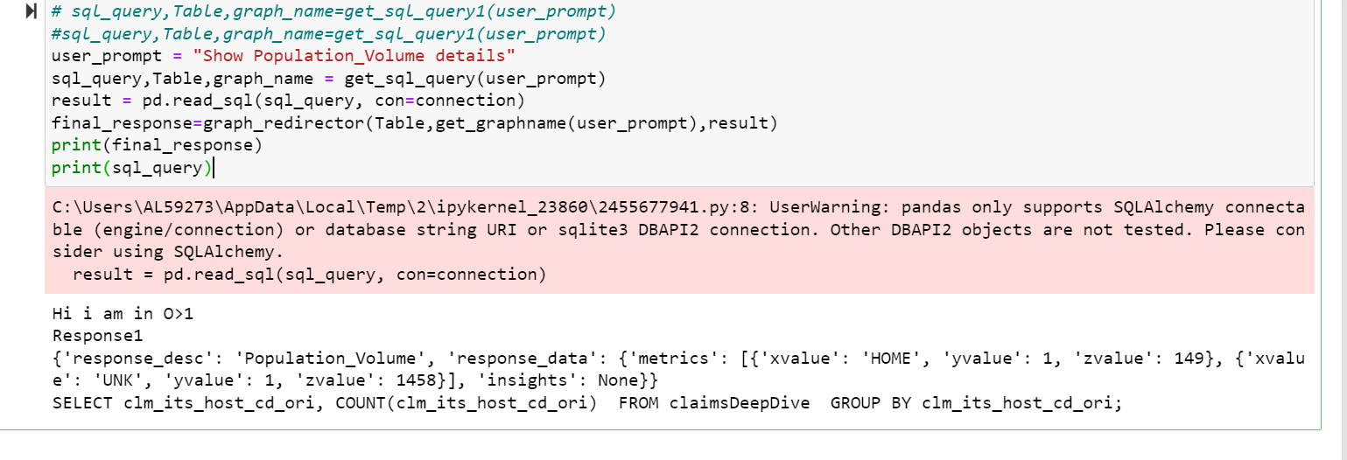

Graph2:Provider status

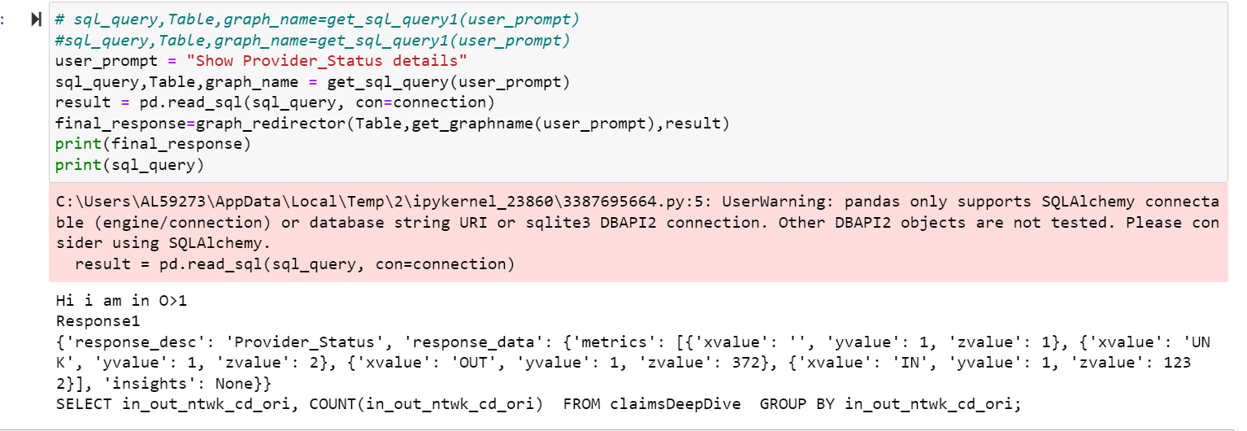

Graph3:

Funding_ID

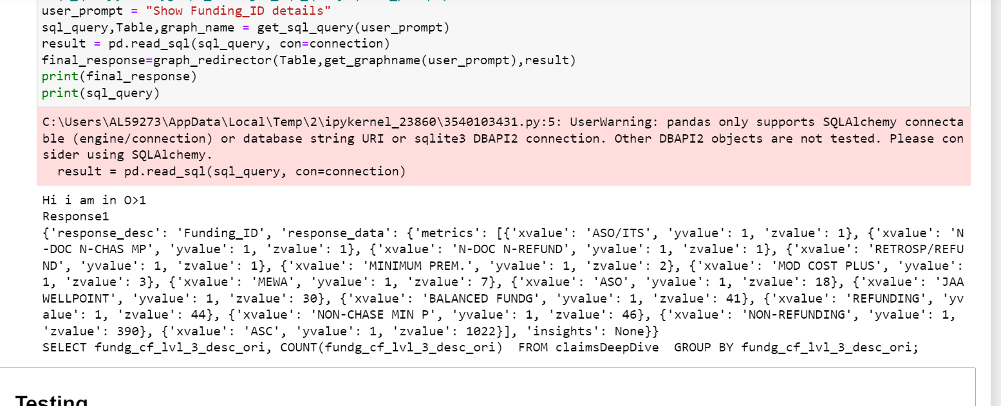

Graph4:

LPP_Claims

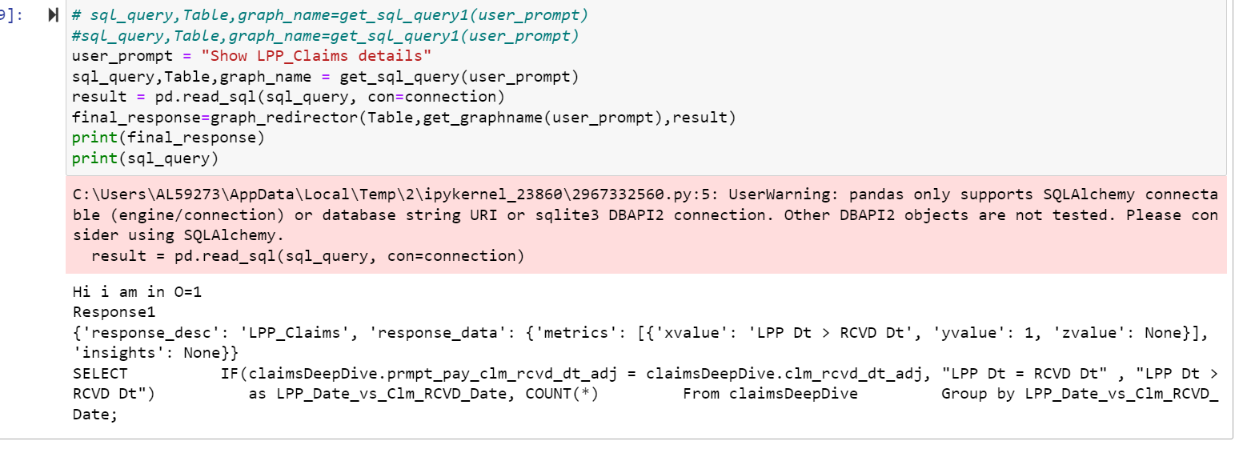

Graph5:

Prompt_Pay

Graph6:

State

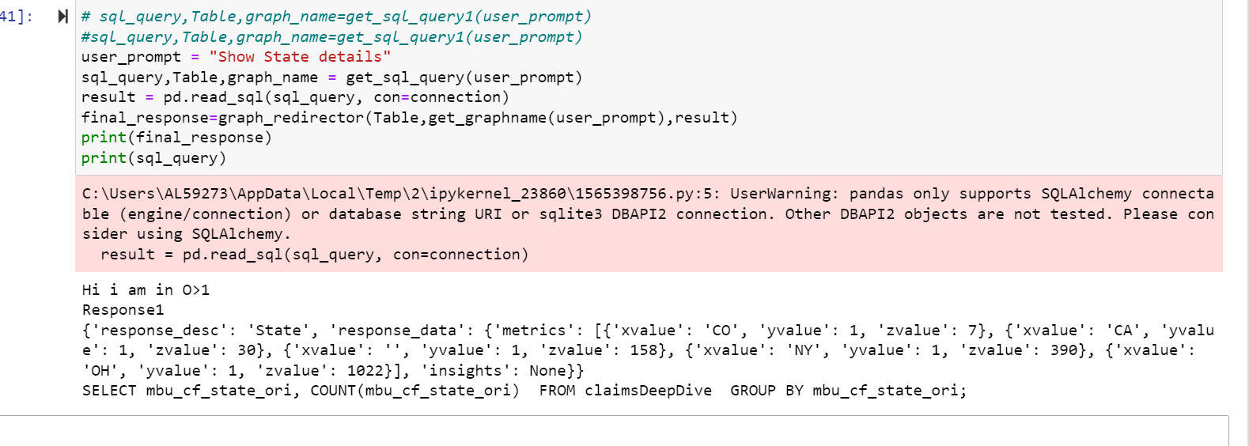

Graph7:

Provider

Graph8:

Group

Graph9:

SubGroup

Graph10:

LOB

Graph11:

Member

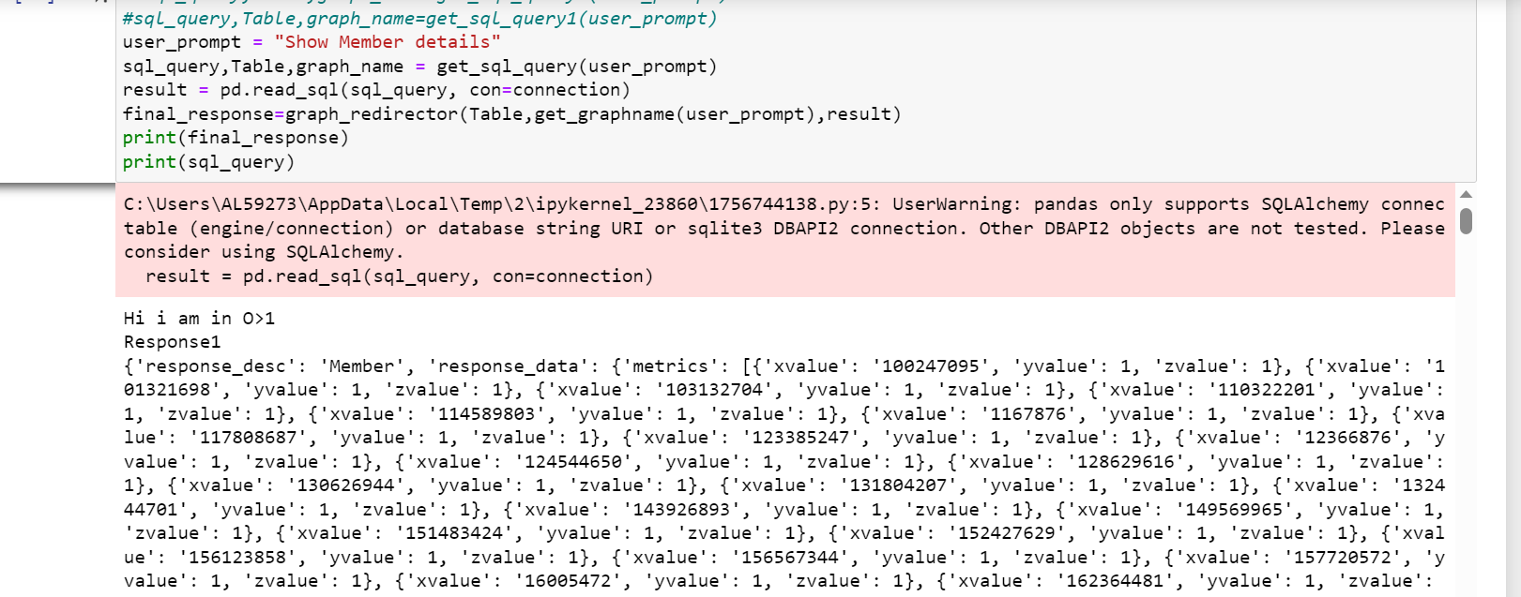

Graph12:

Adj_Reason

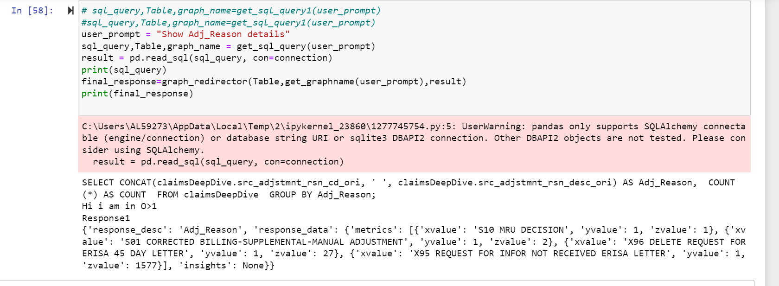

Give your answer as a single word ,only from the below intent list else answer should be None,if you find LPP put it into LPP_Trend_Analysis_Amounts \

Give your answer as a single word ,only from the below intent list else answer should be None,if you find LPP put it into LPP_Trend_Analysis_Amounts or LPP_Claims \